Business Requirements Document(BRD) Template
Project/Initiative
Month 20YY
Version X.XX

Company Information

Document Revisions
Date | Version Number | Document Changes
05/02/20xx | 0.1 | Initial Draft

Approvals
Role | Name | Title | Signature | Date

Introduction

Project Summary

Objectives
-Increase the booking completion rate by reducing barriers that prevent users from completing the booking flow process.
-Provide users with a transparent and convenient booking and payment experience including clear information about the total cost and available payment methods.
-Ensure secure payment processing and protection of users’ payment data in accordance with applicable security requirements.
-Ensure reliable booking confirmation and clear communication of payment and booking status.
-Support the business in maintaining financial security, data protection, and regulatory compliance throughout the booking process.

Background
[Provide a brief history of how the project came to be proposed and initiated, including the business issues/problems identified, and expected benefit of implementing the project/developing the product.]

Business Drivers
[List the business drivers that make development of this product important. These can be financial, operational, market or environmental.]

Project Scope
The project covers the improvement of the payment and booking confirmation process in a hotel booking system. It focuses on providing transparent pricing information, convenient payment methods, secure payment processing, payment status tracking, error handling, and automatic booking confirmation notifications.

In Scope Functionality
- Displaying the full booking cost, including the room price, taxes, cancellation policy, and included services.
- Providing available payment methods, including Apple Pay, Google Pay, card payment, and payment at the hotel where applicable.
- Processing payments through a secure payment gateway.
- Supporting payment authorization/hold or immediate payment.
- Tracking payment and booking statuses.
- Allowing the user to retry a failed payment within 15 minutes while the booking is temporarily held.
- Sending an automatic booking confirmation notification/email after successful payment.
- Providing a booking confirmation in the user's account.
- Protecting users' payment and personal data, including not storing CVV codes and complying with PCI DSS requirements.
- Generating a PDF booking receipt and sending it to the user's email address after payment has been successfully processed.
- Display clear error messages when booking or payment transactions fail.
- Notifications to users about failed actions, including failed payments.

Out of Scope Functionality
- Hotel services and functionality unrelated to payment and booking confirmation.
- Creation or management of hotel prices, taxes, or cancellation policies by hotel staff.
- Development of new payment gateways or payment providers.
- Loyalty and rewards programs.
- Customer support chat for resolving payment or booking issues.

System Perspective
[Provide a complete description of the factors that could prevent successful implementation or accelerate the projects, particularly factors related to legal and regulatory compliance, existing technical or operational limitations in the environment, and budget/resource constraints.]

Assumptions

Constraints

Risks

- .

Issues

Business Process Overview
[Describe how the current process(es) work, including the interactions between systems and various business units. Include visual process flow diagrams to further illustrate the processes the new product will replace or enhance.
Use case documentation and accompanying activity or process flow diagrams can be used to create the description(s) of the proposed or “To-Be” processes.]

Current Business Process (As-Is)
At any point during or after deployment of web apps or web sites (internal or external) to support business activities, development/support teams may create and deploy widgets.
- CMS / database administrators for the employee portal use the CMS tool to create widgets. They can test widgets in the designated staging environment, then register them and deploy to production.
- Development teams may deploy widgets to development and testing environments set up for their development projects. They must check widget code into and out of the source code repository according to their projects’ development schedule.
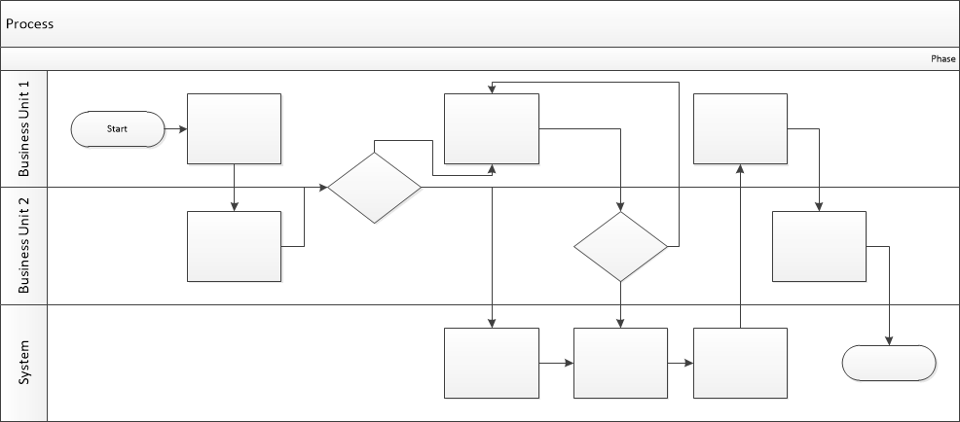

Proposed Business Process (To-Be)
- Technical Lead searches repository
- If widget is not found, user creates a new widget name record.
- WINS validates that all fields have been completed.
- WINS confirms that no similar widgets exist
- User confirms record to be created.
- User searches repository to locate existing widget description.
- WINS displays record
- User selects Edit to open and modify record
- WINS validates all fields completed correctly
- User confirms changes.
- WINS confirms changes and updates Audit table.

Stakeholder Requirements
Users requirements:
SR-01: The user must see the total booking cost before proceeding to payment.
SR-02: The user must see all taxes, fees, the cancellation policy and included services before paying.
SR-03: Users must have convenient payment methods including Apple Pay and Google Pay, by entering a card or the option “Pay upon chek-in” (if offered).
SR-04: Users must receive a booking confirmation via e-mail and be able to view it in “Personal Account” section.
SR-05: Users must be able to track their booking and payment statuses throughout the booking process (ex. Pending -> Paid -> Confirmed)
SR-06: The system shall generate a PDF booking receipt and send it to the user’s email address immediately after successful payment.
SR-07: If a payment transaction fails, the system shall display an error message to users that, if possible, specifies the cause of the error.
Business owner requirements:
SR-08: Payments must be processed securely through a reliable payment gateway.
SR-09: The system must support either a hold or immediate charge, depending on the scenario.
SR-10: Payment and personal data must be secured during the booking payment process.
SR-11: After payment, card CVV codes must not be stored in the system.
SR-12: The system must comply with PCI DSS standards.
SR-13: The user must be able to retry a failed payment within 15 minutes, during which time the system holds the reserved room.
SR-14: The system shall notify users if an operation fails and provide instructions on how to proceed to resolve the issue or retry the operation.

The requirements in this document are prioritized as follows:
Value | Rating | Description
1 | Critical | This requirement is critical to the success of the project. The project will not be possible without this requirement.
2 | High | This requirement is high priority, but the project can be implemented at a bare minimum without this requirement.
3 | Medium | This requirement is somewhat important, as it provides some value but the project can proceed without it.
4 | Low | This is a low priority requirement, or a “nice to have” feature, if time and cost allow it.
5 | Future | This requirement is out of scope for this project, and has been included here for a possible future release.

Functional Requirements
Req# | Priority | Description | Rationale | Use Case Reference | Impacted Stakeholders
General / Base Functionality
FR-G-001 | 1 | Before payment the system shall display the total cost of the reservation, including all taxes and fees. | To allow users to see the total cost of their reservation before completing the payment transaction. |  | Customers
FR-G-002 | 1 | The system shall display the cancellation policy and a list of services included in the booking price before the user makes a payment. | To ensure that users clearly understand the services included in the reservation and the cancellation policy |  | Customers
FR-G-003 | 1 | The system shall offer payment methods available for the selected booking, including Apple Pay, Google Pay, card payment, and “Pay upon check-in” if accepted by the hotel. | To ensure that users can choose the payment method that is most convenient for them |  | Customers, business owner
FR-G-004 | 1 | The system shall support payment authorization (hold) and immediate payment processing through a payment gateway, according to the applicable payment scenario. | To support different payment processing scenarios according to the applicable booking and payment conditions. |  | Business owner, customers
FR-G-005 | 1 | For online payments, the system shall update the booking status to “Paid” after successful payment processing and to “Confirmed” after receiving confirmation from the hotel. | To ensure that the booking status accurately reflects the payment outcome and hotel confirmation. |  | Customers, business owner
FR-G-006 | 1 | If a payment attempt fails, the system shall allow the user to retry payment within 15 minutes while keeping the selected room reserved during this period. | To allow users to retry a failed payment without losing the selected room during the 15-minute reservation period. |  | Customers, business owner
Security Requirements
FR-S-001 | 1 | The system must not store CVV codes after processing a payment for a reservation. | To protect users’ confidential payment information. |  | Customers
Reporting Requirements
FR-R-001 | 2 | The system shall generate a PDF payment receipt after successful payment. | To provide users with a PDF receipt documenting their successful payment. |  | Customers, business owner
FR-R-002 | 2 | The system shall send the generated PDF payment receipt to the user's email address after successful payment. | To ensure that users receive proof of successful payment by email. |  | Customers, business owner
FR-R-003 | 2 | The system shall send a booking confirmation email after the hotel confirms the booking. | To inform users when their booking has been confirmed by the hotel. |  | Customers, business owner
FR-R-004 | 2 | The system shall allow the user to view their booking confirmation in the “Personal Account” section. | To allow users to access their booking confirmation in their personal account. |  | Customers
Usability Requirements
FR-U-001 | 1 | If payment attempt fails, the system shall display an error message that identifies the cause of the failure, where this information is available. | To help users understand payment failures |  | Customers, business owner
FR-U-002 | 1 | If an operation fails, the system shall notify the user and provide instructions on how to proceed or retry the operation, where applicable. | To help users determine the appropriate corrective action. |  | Customers, business owner
Audit Requirements
FR-A-001 | 1 | The system shall record each payment attempt, including its outcome: successful, declined, or failed. | To maintain a record of payment attempts for troubleshooting and payment verification. |  | Business owner

Non-Functional Requirements
[Include technical and operational requirements that are not specific to a function. This typically includes requirements such as processing time, concurrent users, availability, etc.]
ID | Requirement
NFR-001 | The system shall encrypt user and payment data during transmission and storage.
NFR-002 | The payment functionality shall comply with PCI DSS requirements.
NFR-003 | The system shall send an email containing a booking confirmation and a booking receipt in PDF format within 1 minute after the successful transaction that triggered these actions.
NFR-004 | The system shall enforce access controls so that users can access only their own booking confirmations and receipts through the “Personal Account” section.
NFR-005 | The system shall initiate the sending of the booking confirmation email within 1 minute after receiving confirmation from the hotel.

Appendices

List of Acronyms
[If needed, create a list of acronyms used throughout the BRD document to aid in comprehension.]

Glossary of Terms
[If needed, identify and define any terms that may be unfamiliar to readers, including terms that are unique to the organization, the technology to be employed, or the standards in use.]

Related Documents
[Provide a list of documents or web pages, including links, which are referenced in the BRD.]

